**Name**

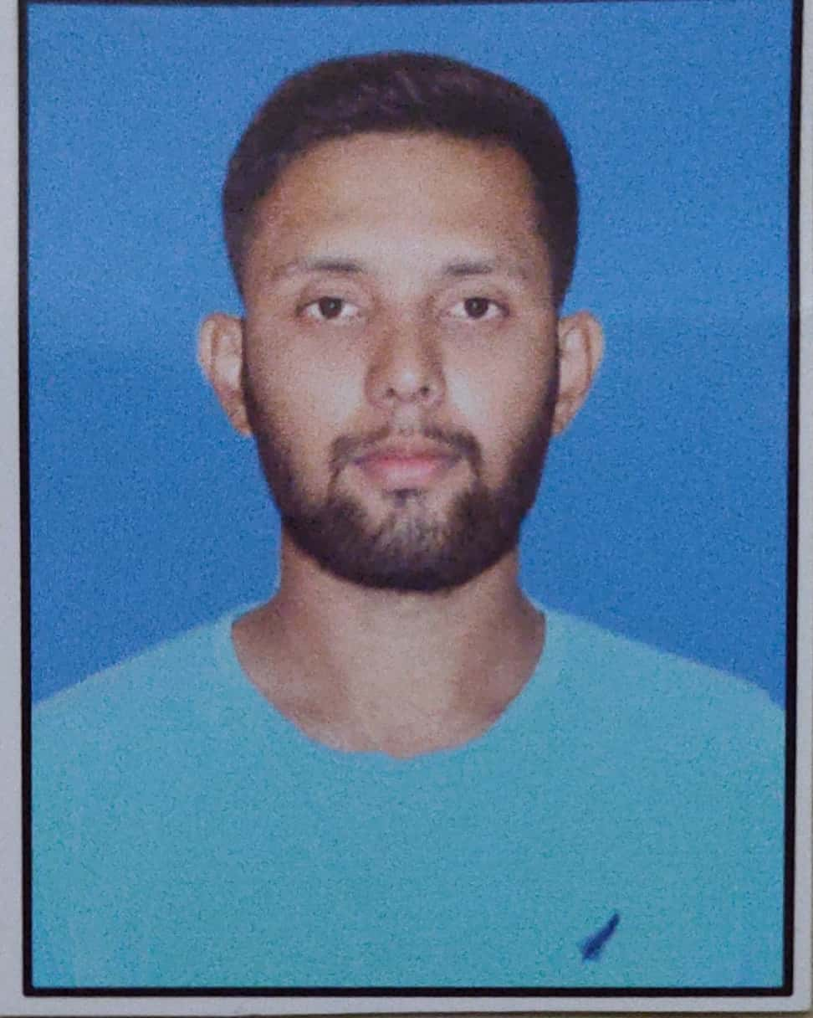l

Profile: Aditya Pravin Sankpal

Contact number: 7721804084

Email id: adityasankpal1999@gmail.com

Current address: At Post Gove, Taluka Satara District Satara

(415015)

**ABOUT ME:**

A meticulous and organized individual seeking an Entry-level position in the organization.

Skilled at cloud computing, DevOps, linux operating system. Strong ability to handle complex project. Innovative, creative, and willing to contribute ideas and learn new things.

**TOTAL WORK EXPERIENCE**

**Education**

|  |  |  |  |  |
| --- | --- | --- | --- | --- |
| Qualification | College name | Board  (City, State) | Graduated Month & year | Percentage |
| Bachelor | **Arvind Gavali College Of Engineering Satara** | **Dr. Babasaheb Ambedkar Technological University Lonere, Raigad** | **August-2021** | **77.10%** |
| Diploma | **Gourishankar Polytechnic Limb,Satara** | **Maharashtra State Board of Technical Education,Mumbai** | **June-2018** | **69.47%** |
| SSC | **Shri Koteshwar Vidyalaya Gove** | **Divisional Board Kolhapur** | **June-2014** | **73.80%** |

**Work Experience**

Duration of work: 0

**Designation: Fresher**

Company name: -

Location: -

Roles and responsibilities: -

Duties: -

**Professional Qualifications and certifications**

**Skills:**

**AWS**: VPC, EC2, EBS, Load Balancing, AWS Database, RDS, Glacier,

Autoscalling, Amazon Machine Image.

**Linux**: Create file, Manage Groups, SEPermissions, Store Logs, Set Ipv4 Addresses,

Archive&Transfer File, Schedule Future Task, ACLs, Logical Volumes, NFS,

Troubleshoot Boot Process, Network Security, Apache Server, RPM

Repositories.

**DevOps**: Github, Chef, Ansible, Docker, Maven, Jenkins.

**Personal Details**

Full name : Aditya Pravin Sankpal

Father's Name : Pravin Maruti Sankpal

Gender : Male

Birthday : 18 Jan 1999

Age : 23

Nationality : Indian

Current address : At Post Gove, Taluka Satara District Satara

Permanent address : At Post Gove, Taluka Satara District Satara

Hobbies : Playing Cricket, Swimming

Languages known : English, Hindi & Marathi

**Declaration**

I, Aditya Pravin Sankpal, hereby declare that the information contained herein is true and correct to the best of my knowledge and belief.

NAME: Aditya Pravin Sankpal

Date: